**To create a credit note** in Adagio Order Entry-Orders

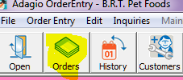

Under the Credit Note tab select New

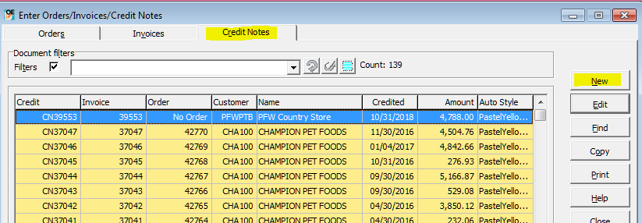

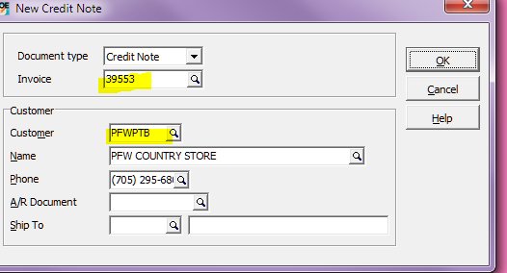

Type in the Invoice# of the Order you want to Credit.

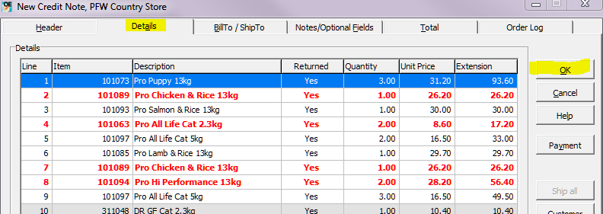

Under the Details tab highlight the item(s) you want to credit and hit OK

**To issue a refund out of Adagio -You must create an Adjustment Debiting the bank.-** See Adjustments Procedudure.